SATISH CHANDRA MEMORIAL SCHOOL
MID TERM EXAMINATION 2023-24
CLASS VII
SCIENCE
Time allowed: 3 Hours Maximum marks: 80

General instructions:
- The question paper consists of five sections named A, B, C, D and E
- There are a total of 39 questions and all are compulsory.
- Section A: Q1 to Q20 are Multiple Choice questions carrying 1 mark each.
- Section B: Q21 to Q26 are Short answer questions carrying 2 marks each.
- Section C: Q 27 to Q 33 are Short answer type questions having 3 marks each.
- Section D: Q 34 to Q36 are Long answer type questions carrying 5 marks each.
- Section E: Q37 to Q39 are Case study questions carrying 4 marks each.
SECTION A
- The generation of suction pull in plants play an important role in moving minerals and water from roots to all parts of the plants. The generation of suction pull takes place due to evaporation of water from the leaves. Which of the factors will favour rapid transport of material in plants?
- Absence of air current
- Increased relative humidity
- Less absorption of water from the soil
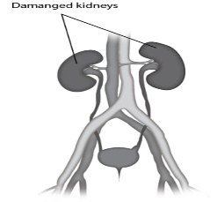
- Increase in environmental temperature
- The image shows a human excretory system in which both the kidneys have been damaged. What likely can happen in this condition?
- Accumulation of waste substances in the blood
- More concentration of carbon dioxide in the blood
- Release of harmful substances in urine in a larger amount
- Accumulation of useful substances in the kidneys and then release out of the body as sweat.
- Human beings have four chambered heart so that the mixing of oxygenated and deoxygenated blood can be prevented. Which of the following describes the implications of the absence of chambers of heart?
- More carbon dioxide will be available to the body cells
- Lesser oxygen will be available to the body cells
- More blood will be available to the body cells
- More pressure would be exerted on the circulating blood
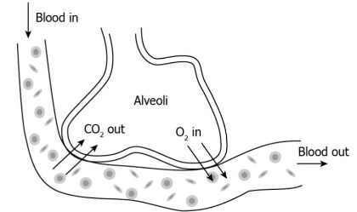
- The image shows alveoli in the human beings. The main function of alveoli is to add oxygen to blood and to take carbon dioxide from blood for releasing out of the body. What structure do insects have that act similar to alveoli?
- Lungs
- Spiracles
- Slimy skin
- Tracheal tubes
- A student observed the image and concluded that this image is depicting respiration in plants. Is the claim made by the student correct?
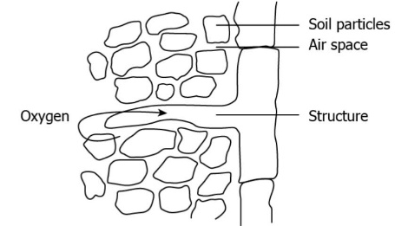
- Yes, this structure is stomata which helps the plant to take in oxygen from the soil
- Yes, this structure is root hair which helps the plant to take in oxygen from the soil
- No, this structure is trachea which helps the earthworm to take in oxygen from the soil
- No, this structure is spiracle which helps earthworm to take in oxygen from the soil
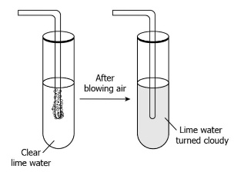
- An experiment was conducted in a class where students were asked to blow air into a test tube containing lime water with the help of a straw. The observation of the experiment was shown in the image. What turns the lime water cloudy?
- Reaction of oxygen gas present in the exhaled air with lime water
- Reaction of all gases present in the atmosphere with lime water
- Reaction of carbon dioxide gas present in the exhaled air with lime water
- Reaction of nitrogen gas present in the atmosphere with lime water

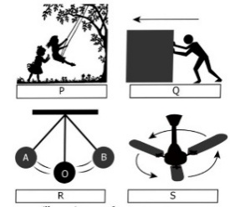
- A few activities are given. Which of these exhibit oscillatory motion?

- P and Q
- P and R
- Q and S
- Q and R

- Boojho visited a forest near his town with his classmates and his teacher. As they were entering the forest, their class teacher told them not to make noise in the forest as noise could disturb
a) birds
b) animals
c) both birds and animals
d) plants
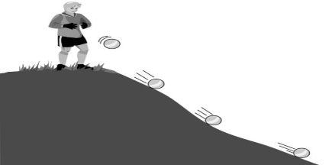
- A student drops a ball from a slope. He notices the ball rolling down as shown in the image. Which of the following statements is true about the motion?

- The student is in motion as he is the top of the slope
- The student is in motion as he drops the ball
- The ball is in motion as it rolls down the slope
- The ball is in motion as its shape changes over time
- An iron weight at 45°C is dropped in a bucket containing water at 45°C. What will happen?
a) Heat will flow from iron weight to water
b) Heat will flow from water to iron weight
c) Heat will not flow between them
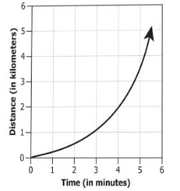
d) Heat will flow and cause increase in temperature of both
- What can be concluded from the distance-time graph of a car given :
- The car has uniform speed as time and distance both are increasing
- The car has uniform speed as the speed does not change
- The car has non-uniform speed as time and distance both are decreasing
- The car has non-uniform speed as the speed keeps on changing
- The table shows the area under the forest in two different regions. Which region is more prone to flood and why?
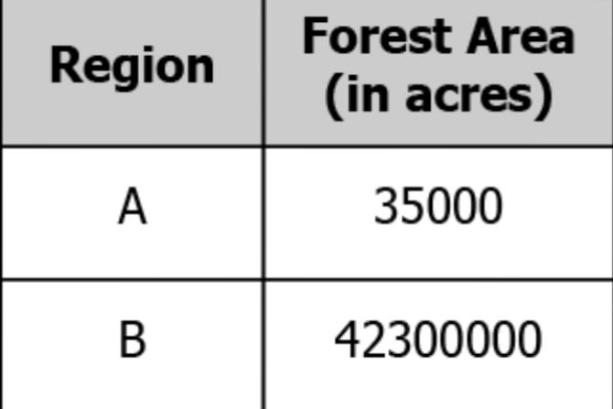
- Region A as it has less trees so more raindrops can hit the ground directly
- Region B as it will have more trees that will prevent the seepage of rainwater into the ground
- Region A as it has less trees that will allow rainwater to sweep rapidly into the ground
- Region B as it has more trees so it can provide more are to the raindrops to hit the ground directly
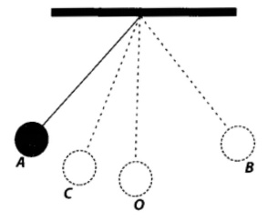
- The figure shows an oscillating pendulum. Time taken by the bob to move from A to C is t₁ and from C to O is t _{2.} The time period of this simple pendulum is
a) (t₁ + t₂ )
b) 2 (₁ + t₂ )
c) 3 (t₁ + t₂ )
d) 4 (t₁ + t₂ )
- Which of the following statements is/are correct?
(i) All green plants can prepare their own food.
(ii) Most animals are autotrophs.
(iii) Carbon dioxide is not required for photosynthesis.
(iv) Oxygen is liberated during photosynthesis.
Choose the correct answer from the options below.
a) (i) and (iv)
b) (ii) only
c) (ii) and (iii)
d) (i) and (ii)
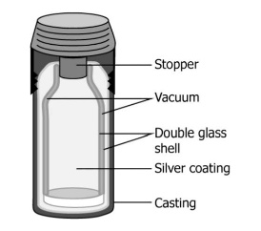
- Observe the given diagram of thermos flask. What is the purpose of vacuum compartment in the thermos flask?
a) It prevents insulation of heat by the bottle’s surface
b) It prevents conduction of heat to the bottle's surface
c) It contains the heat by convection from the liquid
d) It provides radiation of heat within the liquid
16) Pitcher plant traps insects because it
a) is a heterotroph
b) grows in soils which lack in nitrogen
c) does not have chlorophyll
d) has a digestive system like human beings.
17) Turmeric is a natural indicator. On adding its paste to acid and base separately, which colours would be observed?
a) Yellow in both acid and base
b) Yellow in acid and red in base
c) Pink in acid and yellow in base
d) Red in acid and blue in base
18) Assertion (A): The product of photosynthesis is a complex chemical substance called carbohydrate.
Reason (R): The carbohydrate ultimately gets converted into sugar.
- Both A and R are true and R is the correct explanation of A.
- Both A and R are true but R is not the correct explanation of A.
- A is true but R is false.
- A is false but R is true.
19)Assertion (A): Heart is a tissue which acts as a pump.
Reason (R) : Heart is roughly the size of a human fist.
- Both A and R are true and R is the correct explanation of A.
- Both A and R are true but R is not the correct explanation of A.
- A is true but R is false.
- A is false but R is true.

20) Assertion (A) : Neutralisation reaction is accompanied by evolution of heat.
Reason (R) : Neutralisation reaction is a reaction between an acid and a base to form salt and water.
- Both A and R are true and R is the correct explanation of A.
- Both A and R are true but R is not the correct explanation of A.
- A is true but R is false.
- A is false but R is true.

SECTION B

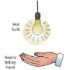
21) Rahul is suffering from the problem of acidity after overeating. Which of the following would you suggest as a remedy – lemon juice, vinegar, baking soda solution? Give reason for your answer.
22) a) Name the mode of heat transfer taking place in the given figure:
b) Suggest another instance in which heat transfer occurs by the same method.
23) Represent a distance – time graph which shows two vehicles move with uniform speed but the speed of vehicle V₁ is higher than speed of vehicle V_{2.}
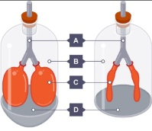
24) “A bunch of seedlings were seen sprouting on a heap of animal dropping in a forest.” How do you think is the seedling benefited from the animal dung?
25) Study the given figure carefully and answer the following questions:
a) Label the parts A, B, C and D.
b) Name the processes exhibited by the first and the second bell jar set up respectively.
26) It is suggested not to over water potted plants. Give reason.

SECTION C

27) A white shirt has a yellow stain of curry. When soap is rubbed on this shirt during washing the yellow stain turns red. On rinsing the shirt with enough water, the red stain turns yellow again.
a) Name the natural indicator present in curry stain. (1)
b) What can you guess about the nature of soap? (1)
c) Name a synthetic indicator which will give pink colour with soap solution. (1)
28) The bulb of the thermometer A is coated with lampblack and the bulb of thermometer B is coated with silver. Both the thermometers are placed in sunshine for equal time.
a) Which thermometer will show a higher rise in temperature? (1)
b) What can be concluded from your observation? (2)
29) Name the type of respiration and give the equation in which the end products are :-
- Alcohol and carbon dioxide
- Carbon dioxide and water
- Lactic acid
30) The organs A of a plant have a large number of tiny pores called B on their surface. Each pore is surrounded by a pair of cells called C. The opening and closing of pores in A is controlled by C. The gas D present in air enters A through B and is utilised in the process E. The gas F produced during E goes out through B. Identify A, B, C, D, E and F. Give the equation involved the process E. (2+1)
31) a) Why is the circulatory system in humans termed as double circulation? (2)
b) Name the large vein that carries blood from chest, shoulder, hands and head to the heart.(1)
32) a) A simple pendulum takes 32 s to complete 20 oscillations. What is the time period of the pendulum? (2)
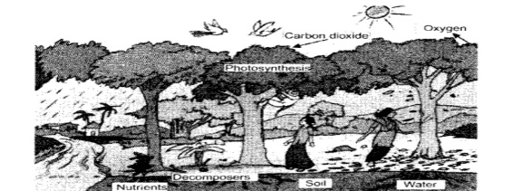
b) What type of motion is shown by a pendulum? (1)
33) The given figure shows a part of a forest.
Write any three activities going on in the forest on the basis of this figure.

SECTION D

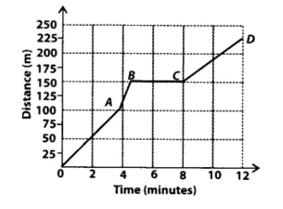
34) Boojho goes to the football ground to play football. The distance-time graph of his journey from his home to the ground is given as figure.
a) What does the graph between point B and C indicate about the motion of Boojho? (1)
b) Is the motion between 0 to 4 minutes uniform or non-uniform? (1)
c) What is his speed between 8 and 12 minutes of his journey? (1)
d) Calculate the average speed of Boojho. (2)
35) Observe the given figure and answer the questions:
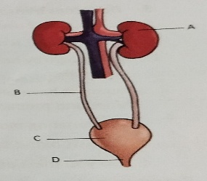
a) Label the parts A, B, C, D. (2)
b) State the functions of part A and C. (1)
c) What will happen if the part labelled A in human body does not function properly? (1)
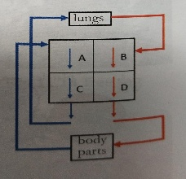
d) State the composition of urine. (1)
36) Observe the given figure and answer the questions that follow:
a) Label the parts A, B, C and D. (2)
b) Which part receives deoxygenated blood from the body tissues. (1)
c) Name the blood vessel that carries blood from lungs to part B. (1)
d) What kind of blood is present in part C?

SECTION E

37) The pH scale shows us how acidic or basic a substance is. The pH value 7 corresponds to neutral. Paheli has taken few of the easily available substances and noted each of the pH value. The pH values of the substances tested are given below.
Pure water -1, Sodium hydroxide – 14, Milk of magnesia – 10, milk – 6, ammonia – 12, vinegar – 5, orange juice – 3, toothpaste -9.
a) Which is the most acidic substance in the list?
b) Which is the most basic substance in the list?
c) What will be the action of phenolphthalein on vinegar?
d) An unknown substance changed the colour of red litmus to blue. What can we say about the nature of the unknown substance?
38)Ravi was suffering from fever and was taken to the doctor for check-up. The doctor measured his body temperature using the clinical thermometer. It is generally a mercury thermometer and uses Fahrenheit scale. This scale starts from 32°F and is divided into 180 equal divisions. Mercury thermometer was invented by Gabriel Fahrenheit in 1714. The doctor also asked him for blood test. The test report showed that the number of white blood cells was very high.
a) Why does most of the thermometers involve the use of mercury? (1)
b) Can we use water instead of mercury in the thermometers? Support your answer with reason. (2)
c) Can we measure our body temperature using laboratory thermometers? Justify. (1)
d) Why do you think the number of white blood cells were very high? (1)
39) A group of students studied the respiratory organs of few animals. There are three animals X, Y and Z. The animal X can stay in water as well as on land and can breathe through its moist skin as well as lungs. The animal Y always lives in water and has gills for breathing. On the other hand, animal Z lives in soil and breathes only through its skin.
a) Which animal could be a fish?
b) Which animal could be an earthworm?
c) Which animal could be a frog?
d) Name one animal which always lives in water but has no gills for breathing.

